March 21, 2025
C964: Computer Science Capstone
Task 2 parts A, B, C, and D
Part A: Letter of Transmittal 3
Part B: Project Proposal Plan 6
Project Summary 6
Data Summary 6
Implementation 8
Timeline 10
Evaluation Plan 11
Costs 13
Part C: Application 16
Part D: Post-Implementation Report 17
Solution Summary 17
Data Summary 17
Machine Learning 18
Validation 18
Visualizations 19
User Guide 23
Reference Page 25

Part A: Letter of Transmittal

07/10/2025
Sage NightOwl
VStreams
123 Streamy Owl Street, Hootsville, UT

Good afternoon Sage,
Streaming services are extremely popular throughout the U.S, They allow people to watch their favorite shows and movies whenever they want. There are so many streaming services to choose from such as Netflix, Disney+, Hulu, Amazon Prime, HBO Max, and many others, that "the average U.S. household is subscribed to around four subscription services" (Jack Caporal, 2025). With the rise of so many streaming services, customers feel like they’re paying the price of cable and are overwhelmed with options. Companies feel that customers are not seeing their content because a show might be popular on one streaming service, and they lose viewership on their platform.
To address this issue the executives at VStreams have secured a deal with Netflix, Disney+, Amazon Prime, and HBO Max. This deal allows VStreams to host all their streaming services and allows VStreams to produce its own original TV shows and movies. This also allows customers to be less overwhelmed with all the streaming options and lower their payments from multiple services to one service. Companies will also benefit from this by having higher viewership because their content will be available alongside other streaming services' content. This would make customers appreciate a specific streaming service, and subscribe to that service to access all of their media. An example of this is that Netflix and Amazon Prime both have TV shows and movies which would also be available on VStreams, however, they also offer the option to play games, which VStreams currently does not offer.
VStreams would benefit from this deal in multiple ways, by being the main host for all these services it would increase the revenue for VStreams as well as increase its name recognition. Since VStreams is unique in the sense that no other service offers multiple streaming services, memberships for VStreams would also increase. Another benefit VStreams gains from this is that Netflix has offered to give us access to their database of movies and TV shows which we could use to help us when we create our own movies and TV shows.
To implement VStreams’ streaming service, a team has put together a summary of the costs, a timeline, data, and any ethical concerns. Costs to get VStreams up and running will be $14,348,996.96. This cost estimate includes cloud storage, hosting costs, developing VStreams' streaming platform, front and back end development, of both the machine learning application and VStreams' streaming service, employee salary, laptops, emergency fund, and maintenance. The timeline will begin with receiving Netflix’s data first as a priority, because VStreams’ developers will create an ML application that will be used to help develop VStreams' original TV shows and Movies, then we will receive the data from Amazon Prime, HBO Max, and Disney+. Once all the data of each streaming service's movies and TV shows have been received and stored on our servers, we will start the development of the platform starting with the back-end. Once the platform is up and running, we will move on to integrating all the individual streaming services into it. The next step will be advertising, which each streaming service has already agreed to push VStreams’ commercial on their platform with commercials, then we will move on to maintenance through VStreams' IT department. After the first year of running services, VStreams will start to release their own original Movies and TV Shows.
Data collection will begin by receiving Netflix's data on their movies and TV shows. Once it is confirmed that VStreams has received Netflix's data, then we will ensure that the data from Disney+, HBO Max, and Amazon Prime can be received. Then the data received from Netflix will be broken down into groups of movies and TV shows, and their ratings. From here the developers will create a machine learning application using Netflix's data, which will show if a type of media is a TV show or movie based on runtime/seasons, and ratings. The executives at VStreams concluded that there are no ethical concerns that are relevant.
My relevant expertise for this project consists of military training, academic training, Project+, ITIL 4, and Linux Essentials certifications. In the Military I worked as a Network Administrator for 4 years, which covered an equivalent of CompTIA A+, and attended classes for Network+, and Security+. My main source to develop the machine learning application is my academic career, which covered Project+, ITIL 4, Linux essentials, industry experience, and research. With my experience, and the development team we have to implement our machine learning application, and VStreams’ streaming service, I am confident that a successful application will be developed and maintained.
Thank you,
Vikas
Sr. Software Developer

Part B: Project Proposal Plan

Project Summary
The current problem the streaming world is facing is that there are so many streaming services that have their own catalog of movies and shows including their own original movies and TV shows. This can cause customers to feel overwhelmed by the amount of money they have to pay for all these streaming services. Streaming companies also face the issue of losing out to their competitors because people usually stay on one platform when streaming, rather than browsing the many streaming apps that they have. Since both the customers and the companies are facing issues, VStreams is proposing to create its own platform that combines the streaming services Netflix, Disney+, HBO Max, and Amazon Prime. In addition to providing a platform for customers to access these streaming platforms, VStreams will also make its own original movies and TV shows.

Data Summary
The source of the raw data needed will be provided by the streaming services and will be collected by the IT department at VStreams. The initial data collection will first be conducted from Netflix because VStreams' will be basing a machine learning application on their specific data. Once the data from Netflix is confirmed to have been received by VStreams' I.T. department, then a request will be sent out for Amazon Prime, HBO Max, and Disney+ to send their data to VStreams’ I.T. department.
During the design phase of the SDLC developers at VStreams will use Netflix's data in the form of a CSV to train their Machine Learning application. The data will be broken up into movies and TV shows. Then they will move to the implementation phase where the provided data from Netflix will be processed, checked to ensure the data's integrity and accuracy. The data will then be broken down by ratings, runtime, and seasons, and will be used for machine learning. The data will be split into 80% for training, and 20% for testing when the Logistic Regression model is created. Then the developers will implement a user interface to allow users to adjust sliders which will show a number of seasons or runtime, and a rating, when they click the predict button, the application will output whether those parameters are a TV show or a movie. Testing will be conducted during the implementation phase to ensure any issues are dealt with in a timely manner. Once the application is completed and verified for no bugs, it will be moved to the deployment phase to allow the employees at VStreams to determine if they're creating a movie or TV show based on the rating, runtime, and seasons. Then the application will be in the maintenance phase to address any bugs that arise and update or fix anything that comes up.
The data meets the needs of the project because VStreams is planning on creating its own original TV shows and movies. Having access to Netflix's data allows employees at VStreams to better gauge what a TV show is vs a movie, and since Netflix's data consists of a large amount of TV shows and movies including their own originals, it is the ideal data set to use. In the case of anomalies, the specific data will be disregarded. There are no ethical or legal concerns regarding the data because Netflix's specific data is being given by Netflix for VStreams to use, and the other streaming services are also willingly giving their data.

Implementation
The implementation method that VStreams will use to develop its machine learning application is CRISP-DM. CRISP-DM stands for Cross-Industry Standard Process for Data Mining and "includes descriptions of the typical phases of a project, the tasks involved with each phase, and an explanation of the relationships between these tasks" (IBM, 2021). The phases of the CRISP-DM are:
- Business Understanding: The executives of VStreams, Netflix, Disney+, Amazon Prime, and HBO Max have conducted a meeting and determined that the business problem they are facing is how to lower consumer costs, while still being able to increase their viewership of their media against their competition. During their meeting they have defined the objective is to prioritize VStreams as a platform that will host most of their media containing movies and TV shows while VStreams puts out their own original movies and TV shows in the future. To do this VStreams will develop a machine learning application using Netflix's data to categorize movies and TV shows. The success criteria will be determined by seeing how much viewership VStreams has compared to the other streaming services not included in this merger.
- Data Understanding: During this phase department heads from Netflix, Disney+, Amazon Prime, and HBO Max will send their data to the IT department at VStreams. The initial data collection will be from Netflix to VStreams because they are creating their machine learning application based on Netflix's data. Once Netflix's data is received, Disney+, Amazon Prime, and HBO Max will send their data to the IT department at VStreams. The data received from Netflix will be reviewed by developers at VStreams to implement their machine learning application, they will implement a bar chart to show the difference between tv shows and movies, a histogram to show how many titles were released within a specific year, and a pie chart to show the difference in ratings.
- Data Preparation: The developers at VStreams will prepare the data by breaking the types of media into TV shows and movies. Any data that is not usable will be discarded since Netflix has a big dataset, and this should not be a problem. The other streaming services' data will go straight to being implemented on the VStreams streaming platform since their data is not being used to create the VStreams machine learning application.
- Modeling: Developers at VStreams have determined that the best model to use for this data will be the Logistic Regression model. The data received from Netflix will be split up to be used for training and testing the model.
- Evaluation: The developers at VStreams will conduct an evaluation of the machine language's accuracy and performance on the data given by Netflix. After the evaluation is completed, the developers will review any issues that arise, and ensure performance is accurate. A senior developer at VStreams will determine if the application is fully ready for deployment.
- Deployment: While VStreams’ streaming application will be functional and running Netflix, Disney+, Amazon Prime, and HBO Max, the machine learning application will be available for VStreams’ employees. Employees at VStreams will be able to use the newly created machine learning application to determine what a TV show vs a movie is using the runtime, season, and rating. This will be useful when VStreams starts making their own original TV shows and movies. It will be available through VStreams SharePoint and access will be given through the IT department. VStreams' I.T. department will also be given a copy of the documentation and the developers will have a meeting with upper management to discuss anything that went wrong and areas that can be improved.

Timeline
Milestones | Resources | Dependencies | Start and End Dates | Duration
Streaming services executives conduct their meetings. | Google calendar | Executive’s schedule availability | 08/04/2025 - 08/15/2025 | 12 days
Receive and Verify Netflix’s Data. | I.T. Department | Executive meeting, Netflix, I.T. department | 08/18/2025 - 08/25/2025 | 7 days
Receive and verify Amazon Prime, Disney+, and HBO Max's data. | I.T. Department | Netflix, IT department | 08/28/2025 - 09/08/2025 | 12 days
Develop the VStreams streaming platform and machine learning application. | VStreams Developers and Machine Learning team | Streaming Services data, I.T. department | 09/09/2025 - 12/17/2025 | 100 days
Deploy VStreams' streaming service, and conduct tests and check for bugs on VStreams’ machine learning application. | QA team, Machine Learning Team | I.T. department, streaming platform completion, and machine learning application completed | 12/22/2025 - 12/22/2025 | 1 day
Staff receive VStreams’ machine learning application | I.T. Department, company-wide | I.T. department | 01/07/2026 - 01/09/2026 | 3 days
Conduct a review with the development team to see what could be improved on or any issues that arose. | Developers, ML Team, Management | Streaming platform completed, Machine learning application completed | 01/12/2026 - 01/21/2026 | 10 days

Evaluation Plan
To ensure verification of VStreams' streaming application and machine learning application, code reviews will be conducted by senior coders. Developers will write code to omit missing data or data that cannot be used. During each major phase of coding, unit, integration, and accuracy tests will be conducted to ensure that the streaming application and the machine learning application will be functioning properly. During each streaming platform's integration, another test will be conducted to ensure that no content is missing and that the platform's media is being displayed. If anything goes wrong during an implementation, the development team will receive an error, and the issue will become a priority for senior developers to fix the error. These verification methods will ensure properly functioning applications for streaming users, and the employees at VStreams.
Validation methods performed at VStreams will ensure that specific targets are being met. The developers at VStreams will be required to have 80% accuracy for both the machine learning application and the VStreams streaming application. Another validation requirement will be for the developers to implement a confusion matrix for the machine learning application to test the application's predictions.
Prior to deploying VStreams' streaming platform, executives and senior managers will be given a beta version of the application to perform User Acceptance Testing (UAT). This will be done to ensure that the application meets the executives' and management's expectations. There will be a select group of senior developers and QA to conduct UAT on the machine learning application to ensure that it is performing as expected. After positive results from the UAT receiving satisfaction and no feedback from them, and signing off from management and executives, support will be moved to VStreams' IT department to assist everyday users.

Costs
Resource | Description | Cost
Data Sets | Netflix, Amazon Prime, Disney+, and Hulu’s data | $0.00 (given by executives for the merger)
Development Tools | (“ThinkPad X9 15 Aura Edition Intel (15”)” Laptop, IDEs (Visual Studio Code), Python, and machine learning libraries (pandas, matplotlib, seaborn, numpy, sklearn, ipywidgets, IPython, documentation) | $ 30,396.96 (18 laptops x 1688.72)  $0.00 (Open-source)
Development Team | 4 software engineers, ($65.00 per hour per employee x 2000 working hours per year = $130,000)  4 machine learning engineers, ($70.00 per hour per employee x 2000 working hours per year = $140,000)  2 data scientist, ($63.50 per hour per employee x 2000 working hours per year = $127,000)  2 senior developers, ($100.00 per hour per employee x 2000 working hours per year = $200,000)  1 project manager, ($52.00 per hour per employee x 2000 working hours per year = $105,000)  3 I.T. employees, ($40.00 per hour per employee x 2000 working hours per year = $80,000)  2 QA employees ($43.50 per hour per employee x 2000 working hours per year = $87,000) | SWE - $520,000 ($130,000 x 4)  MLE - $560,000 ($140,000 x 4)  DS - $254,000 ($127,000 x 2)  SD - $400,000 ($200,000 x 2)  PM - $105,000  I.T. - $240,000 ($80,000 x 3)  QA - $174,000 ($87,000 x 2)
Cloud Hosting | AWS | $12,000,000 (1,000,000 per month x 12)
Other | Travel, office lease, emergency fund | $0.00 (Workers are remote so no travel or office lease)  $65,000 (emergency fund)
Total |  | $14,348,996.96 per year

Part C: Application
- The Jupyter Notebook file called “Vikas Lohana C964 Capstone Netflix.ipynb" is made available for anyone with the Google Colab link. Evaluation Link: https://colab.research.google.com/drive/1ZEyu8u42xCP3tpbWBm16NQnIx7id5i6D?usp=sharing
- A copy of the dataset has also been attached and called “netflix_titles.csv”.
- A copy of the source code called “capstone.py" has also been added.

Part D: Post-Implementation Report

Solution Summary
Due to the rise in streaming services, many customers are tired of paying a lot of money to have multiple streaming services. With customers having multiple services, many of the streaming platforms they have are going unused. Typically, when a customer is on one platform, they stay on that platform. With customers having so many options due to streaming and its price, it feels like cable has come full circle. The executives at Netflix, Disney+, HBO Max, and Amazon Prime have decided to come together to bundle their services with VStreams to help lower customer costs. This will allow customers to pay a lower cost while still being able to view those streaming services' movies and TV shows through VStreams as the main platform. While each streaming service has its own original TV shows and movies, VStreams will be creating their own too using Netflix's data to assist them. The developers at VStreams will create a machine learning application to help the employees at VStreams determine what is a movie or TV show from Netflix's data. This will be used to help create VStream's original movies and TV shows.

Data Summary
The data has been given to VStreams by Netflix, HBO Max, Disney+, and Amazon Prime since they will all be merging into one streaming service. Netflix's data will be the first set of data given to VStreams since the developers at VStreams will be creating a machine learning application from it. Once VStreams' I.T. department has received Netflix's data, Amazon Prime, HBO Max, and Disney+ will be able to send their data to the I.T. department at VStreams. Once all the data has been received, the developers at VStreams can also begin working on creating the VStreams streaming platform and integrating all the streaming companies' data. Due to Netflix's huge catalog, any data that is unusable will be discarded and not used.

Machine Learning
The model of machine learning that the developers at VStreams used is the logistic regression model to classify Netflix's data in terms of movies and TV shows. The logistic regression model is a supervised learning model for binary classification, Movies are assigned the value of 0, while TV shows are assigned the value of 1. To allow the model to make predictions, the values used for input are the ratings, the runtime in minutes, and the number of seasons. The type value is used for the output. These values are used to train the model and predict data belonging to a category such as a movie or TV show.

Validation
To demonstrate validation in VStreams' machine learning application, the data received from Netflix was split into 2 sections, one for testing, and one for training. 80% of the data received is put into training, while 20% is used for testing. The data that was used for testing is compared to the data used for prediction to determine accuracy, and then it is printed. An accuracy score above 80% is accurate. The same data is also put into a confusion matrix to show the correct and incorrect classification of movies and TV shows. Users can verify the validation by running the code, an accuracy score will print where “Accuracy: “ is stated, and a score above 80% is considered passing, the confusion matrix table is also printed under where “Confusion Matrix:” is stated. The first line demonstrates movies that are predicted correctly vs movies that are not, the second line prints TV shows that are predicted correctly vs TV shows that are not. A passing rate for the confusion matrix is to have fewer than 10 improperly predicted TV shows or movies.

Visualizations
VStreams' machine learning application provides 3 images to show the difference in movies and TV shows, ratings, and years of release. These visualizations were chosen because they show important factors in developing the code.
Bar Chart to show the difference between movies and TV shows: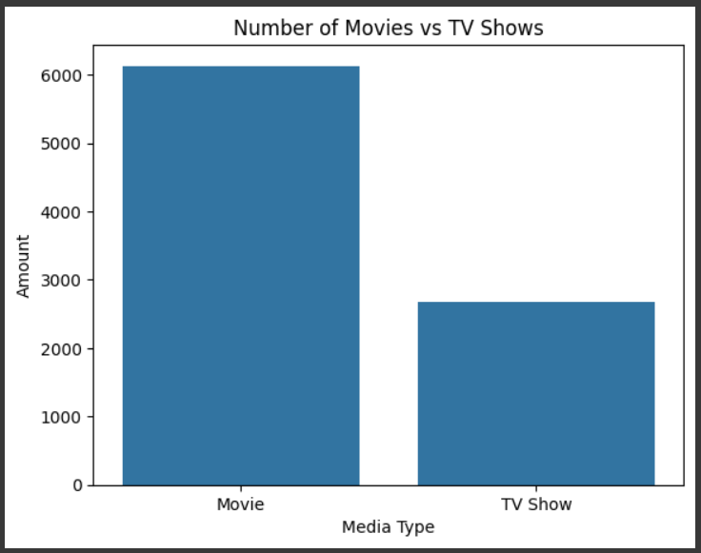

A histogram to show the difference between titles being released in which year:
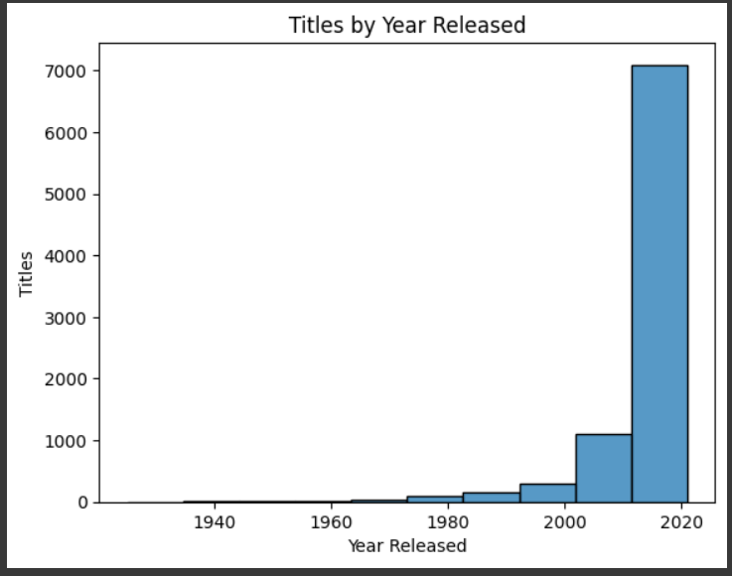

Pie chart to show the difference in ratings:
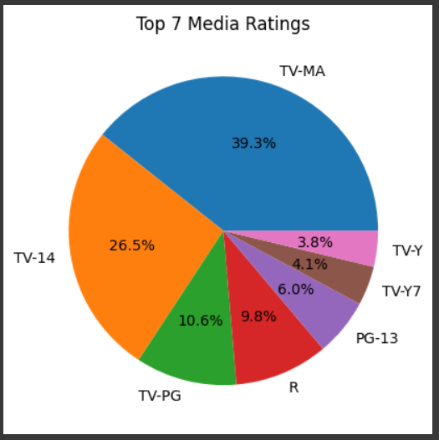

User Guide
VStreams' machine learning application was created to support the staff at VStreams in determining how to categorize VStreams' original media such as movies and TV shows. Every block of code contains comments on what the code does. Using Netflix's data allows the employees at VStreams to better determine what to categorize as a movie or TV show using the run time, seasons, and ratings. If the prediction outputs a 0, the media would be a movie, if it outputs a 1 then it would be a TV show. For employees to use the code, they would click the 'run all cells' button. For a more in-depth direction follow these directions:
- Open an internet browser, and make sure you have a Google account. If you have a Google account move on to step 2, If you don't have a Google account then move to step a.
  - Click the "for my personal use" button from the drop-down
  - Input your first and last name
  - Enter your birthday and gender
  - Pick an email address you want to use
  - Pick a password
  - Enter your phone number for verification
  - Agree to the terms
  - You now have a Google account and can view VStreams' machine learning application by clicking the link.
- Once signed into Google, click this link to access VStreams' machine learning application, you won't have to download anything or save any files: https://colab.research.google.com/drive/1ZEyu8u42xCP3tpbWBm16NQnIx7id5i6D?usp=sharing
- Click the “Run all” button, which is located below the orange "CO", and 3 buttons down from the "Commands" button.
- A pop-up will display and state "Warning: This notebook was not authored by Google" click the "Run anyway" button on the lower right of the pop-up.
- The program is now fully running, and all the images have appeared, scroll all the way down to the scroll bar widgets.
- Now you can input runtime, seasons, and a rating, and click the "predict button". The output will be below the “Predict” button next to the key. An output of 0 is a movie, and 1 is a TV show as described in the key.

Reference Page
Caporal, J. (2025, May 22). Study: 62% of streaming service subscribers say there are too many options. The Motley Fool. https://www.fool.com/research/state-of-streaming/
IBM. (2021, August 17). CRISP-DM Help Overview. CRISP-DM help overview. https://www.ibm.com/docs/pt-br/spss-modeler/saas?topic=dm-crisp-help-overview
Lenovo. (n.d.). Thinkpad X9 15 Aura edition (15ʺ Intel): COPILOT+ PC with AI Power & Efficiency. ThinkPad X9 15 Aura Edition (15ʺ Intel) | Copilot+ PC with AI Power & Efficiency | Lenovo US. https://www.lenovo.com/us/en/p/laptops/thinkpad/thinkpadx9/thinkpad-x9-aura-edition-15-inch-intel/len101t0111

